**SUMMARY OF COVID REPORT IN GERMANY (AS OF LAST UPDATED DATA)**

**Description of the dataset and variables:**

The dataset is from this Kaggle source: <https://www.kaggle.com/datasets/headsortails/covid19-tracking-germany>. The data is a compilation of COVID-19 data gathered and collected upon first discovery. As the author has noted, “This dataset provides daily updated number of reported cases & deaths in Germany on the federal state (Bundesland) and county (Landkreis/Stadtkreis) level. In April 2021 I added a dataset on vaccination progress. In addition, I provide geospatial shape files and general state-level population demographics to aid the analysis.” The dataset includes several files which are covid_de.csv, demographics_de.csv, covid_de_vaccines.csv, and de_state. For the data visualization, only covid_de.csv is or predominantly used. The column descriptions for this file, as the author has noted include:

* **state:** Name of the German federal state. Germany has 16 federal states. I removed converted special characters from the original data.
* **county:** The name of the German Landkreis (LK) or Stadtkreis (SK), which correspond roughly to US counties.
* **age_group:** The COVID-19 data is being reported for 6 age groups: 0-4, 5-14, 15-34, 35-59, 60-79, and above 80 years old. As a shortcut the last category I'm using "80-99", but there might well be persons above 99 years old in this dataset. This column has a few NA entries.
* **gender:** Reported as male (M) or female (F). This column has a few NA entries.
* **date:** The calendar date of when a case or death were reported. There might be delays that will be corrected by retroactively assigning cases to earlier dates.
* **cases:** COVID-19 cases that have been confirmed through laboratory work. This and the following 2 columns are counts per day, not cumulative counts.
* **deaths:** COVID-19 related deaths.
* **recovered:** Recovered cases.

**Discussion of questions and the story:**

The purpose of the Tableau visualizations in this project is to tell the story of COVID-19, the COVID-19 pandemic, and the effect of COVID-19 on Germany as a case study. There are 6 worksheets, 2 dashboards, and one story to tell at least a partial story of Germany’s experience with COVID-19. Each section gives a general overview of COVID-19 in Germany from the year 2020-2023 along with a focus exclusively on the year 2022.

1. **The Trend of COVID-19 Deaths in Germany from Year 2020-2023.**

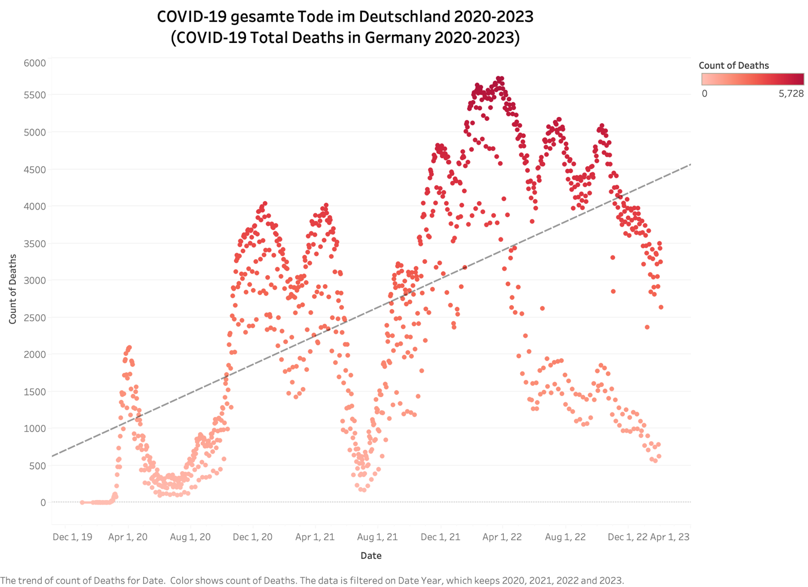

In the graph (above), you can see that from the first initial infection of an individual in Germany, the cases of COVID-19 have substantially increased over time with 6 peaks from 2020-2023. The count of deaths serves as a range of how many people have died from COVID-19 with a maximum on a particular day of 5,728. The trendline seems to show that cases will continue to exponentially increase over time, which is not the case.

This graph (above) shows that the trendline is not as high as one would assume when filtering for the year 2021-22.

This graph (above) shows that the trendline is decreasing when filtering for the year 2022.

1. **Overview of COVID-19 in Germany from Year 2020-2023**

This bar graph (above) shows that the most devastating period for Germany was the year 2022, which has a total death count roughly equal to the year 2020 and 2021.

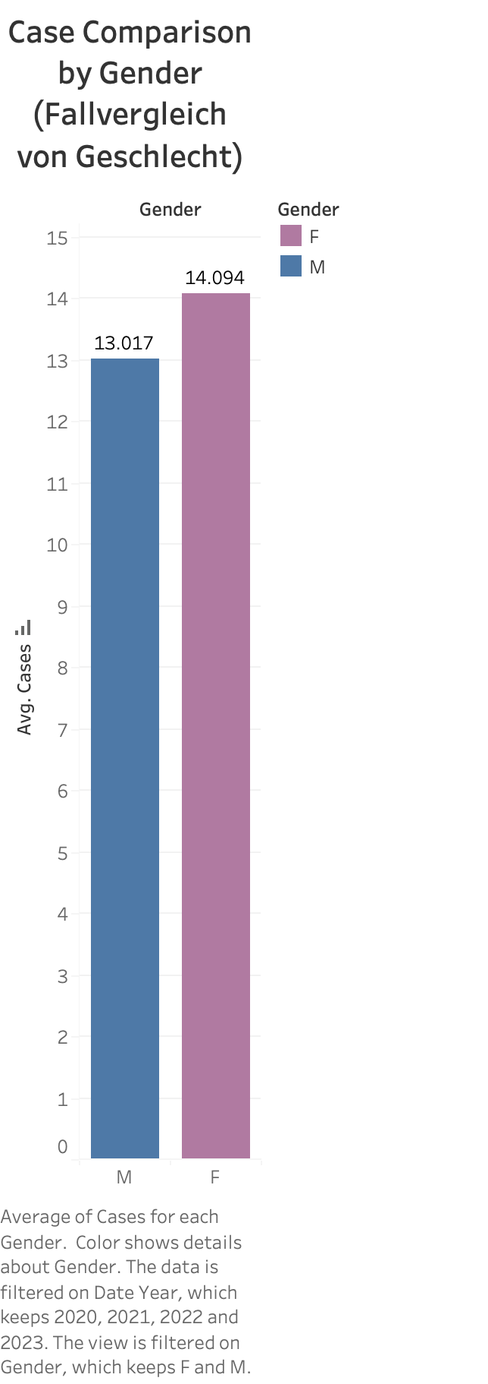

This bar graph (above) shows that for every male (M), there were 13 cases of male, and for every female (F), there were 14 cases for the year 2020-2023.

This bar graph (above) shows that for every male (M), there were 21 cases of male, and for every female (F), there were 23 cases for the year 2022. It appears that more females than males are exposed to contracting COVID-19 cases.

The purpose of this bubble map (above) is to illustrate which German provinces had the most cases of COVID-19. As you can see, provinces, such as Baden-Wuerttemberg and Bayern, are some of the provinces with the most cases of COVID-19 from 2020-2023.

This same bubble map (above) demonstrates no significant changes for Baden-Wuerttemberg and Bayern when filtering for some of the most cases of COVID-19 by German provinces for the year 2022.

The purpose of the table (above) is to highlight the severity of COVID-19 cases for each province, distinct count of deaths (assume confirmed and not counted twice), and distinct count of recovered (assume confirmed and not counted twice). If the count of deaths and recovered were not distinct, the data would be the same as the count of cases for each province. For the year 2020-2023, you can see that the most serious cases of COVID-19 are for the provinces of Baden-Wuerttemberg and Bayern for count of cases, deaths, and recovered. Another province of concern is Nordrhein-Westfalen.

Looking at this same table (above) for the year 2022, you can see that the most serious cases of COVID-19 are for the provinces of Bayern, Niedersachsen, Nordrhein-Westfalen for count of cases, deaths, and recovered.

Examining the affected age group in Germany, regardless of year 2020-2023 and year 2022, the most affected age groups are 35-59, 60-79, and 80-99. This is in alignment with the consensus that COVID-19 was more severe for older people in terms of likelihood of death (black line mark). However, the count of cases is roughly proportional for all age groups.

1. **COVID-19 and Germany**

COVID-19 in Germany for year 2020-2023 (below)

COVID-19 in Germany for year 2021-2022 (below)

COVID-19 in Germany for year 2022 (below)

COVID-19 in Germany (part 2) for year 2020-2023 (below)

COVID-19 in Germany (part 2) for year 2021-2022 (below)

COVID-19 in Germany (part 2) for year 2022 (below)

**Summary of business implications and recommendations based on the results:**

The report demonstrated Germany’s failure to contain and mitigate the effects of COVID-19 on its population, despite Germany’s best efforts. This is illustrated through a large spike of COVID-19 cases in 2022. Although the number of cases by gender is not drastic, some of Germany’s provinces were hit harder by COVID-19 than others. Moreover, Germany’s older population were more at risk of death from COVID-19, which is not a surprise due to greater severity for older individuals. Due to the COVID-19 pandemic affecting Germany and that there were economic disruptions, Germany’s economic outlook could have been better for the foreseeable future if the COVID-19 pandemic had not happened. A recommendation would be for Germany to be better prepared for the next pandemic, which means stockpiling medical resources and funding both government and non-government health institutions for research into infectious disease and pandemic-policy planning.